**COMM 204**

**2018W1 Final Review Package**

Will Zhang



**Table of Contents**

1. Variability: M/M/c
2. Project Management
3. Inventories: EOQ
4. Inventories: Newsvendor
5. Inventories: Lead Time
6. Forecasting
7. Practice Problems
8. Solutions

**Variability: G/G/c**

**Recall P-K Formula to find average queue length:**



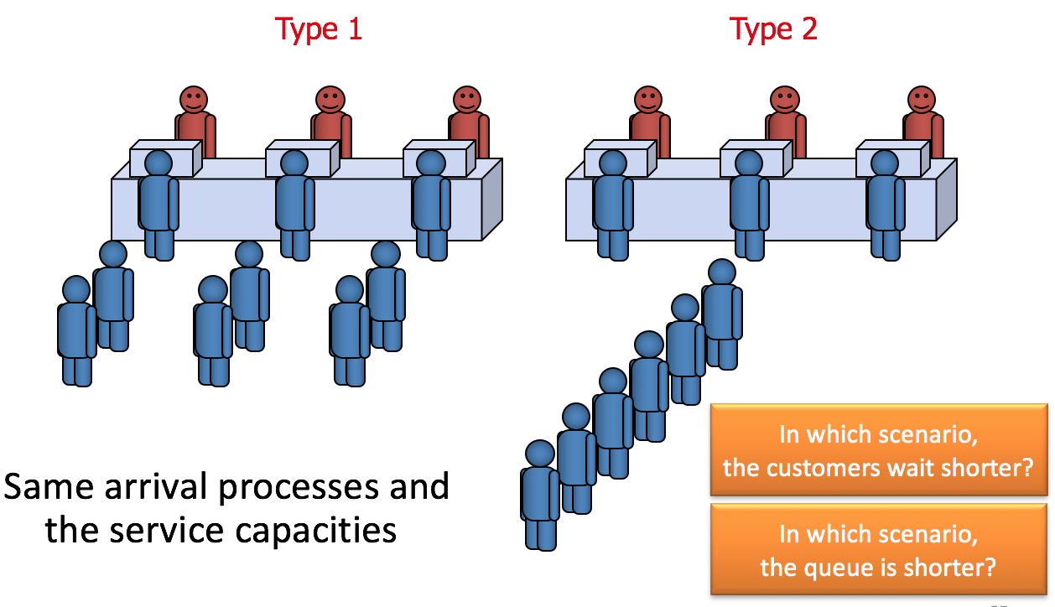

If you have multiple servers with a single queue (Type 2 above), this formula becomes

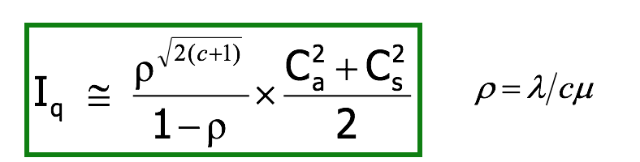

Compared to Iq for Type 1 (simply 3x G/G/1), Iq for Type 2 will be lower. Tq will be shorter due to “risk-pooling”; some mathy stuff.

For M/M/c, ignore the right term with the Ca and Cs stuff (just use the half of the formula with rho).

**Project Management**

A project is essentially a bunch of resources working towards a common goal. There are many ways to plan and visualize a project schedule. We have the Gantt chart as described before the midterm in process mapping, and the critical path diagram.

**Gantt Chart:**

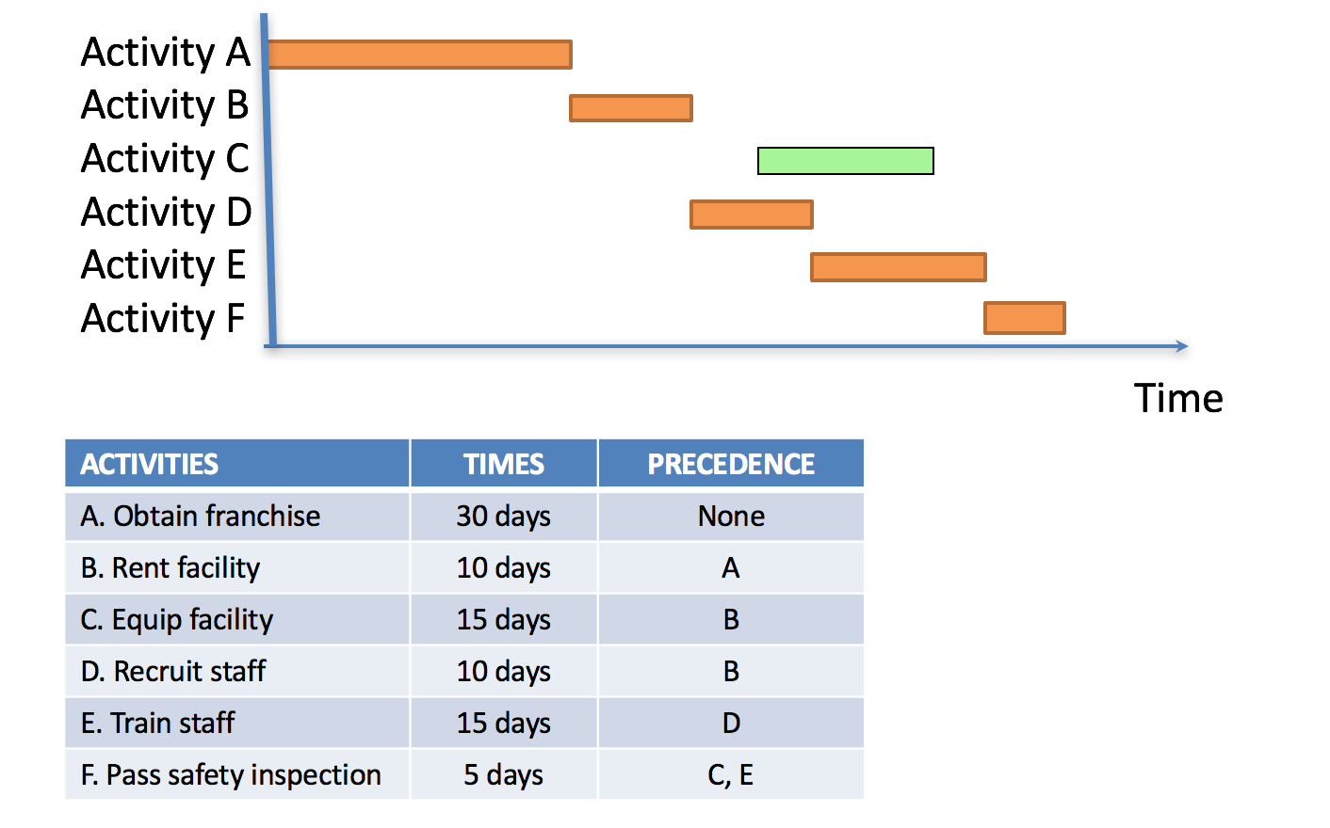

**Critical Path Diagram (Critical Path Method/CPM):**

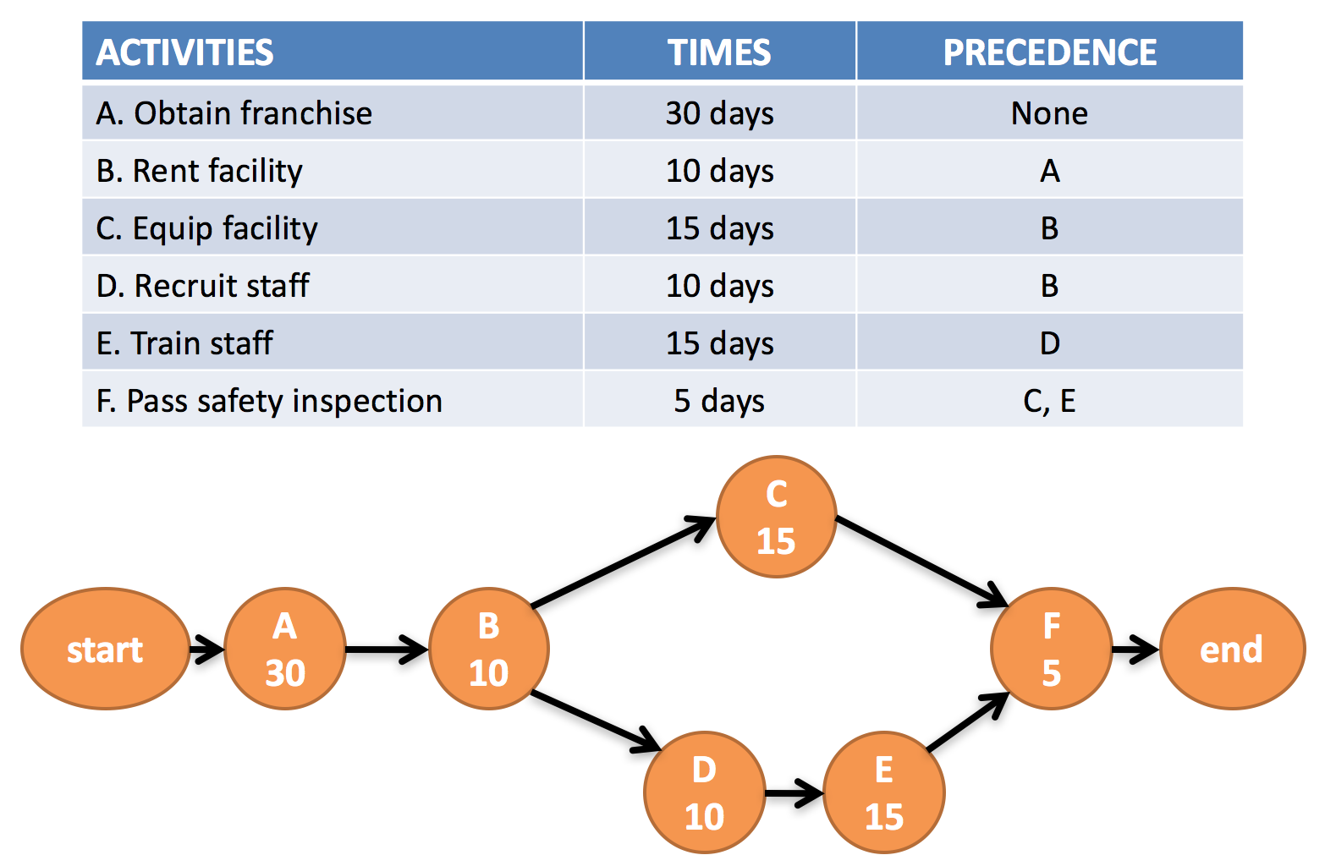

How do you draw this thing? Just draw activities from the beginning, then draw arrows that point to their dependents (so C and D are dependents of B). Add times. For each path, (A 🡪 B 🡪 C 🡪 F 🡪 End or A 🡪 B 🡪 D 🡪 E 🡪 F 🡪 End), add the times up to see how long the path takes. The path that takes the longest is of course the critical path, which, like the bottleneck in a process map, determines how long your project is.

All activities on the critical path are critical activities

Any delay in critical activities will delay the whole project

This information allows us to allocate resources among activities to find appropriate tradeoffs between project duration and project cost

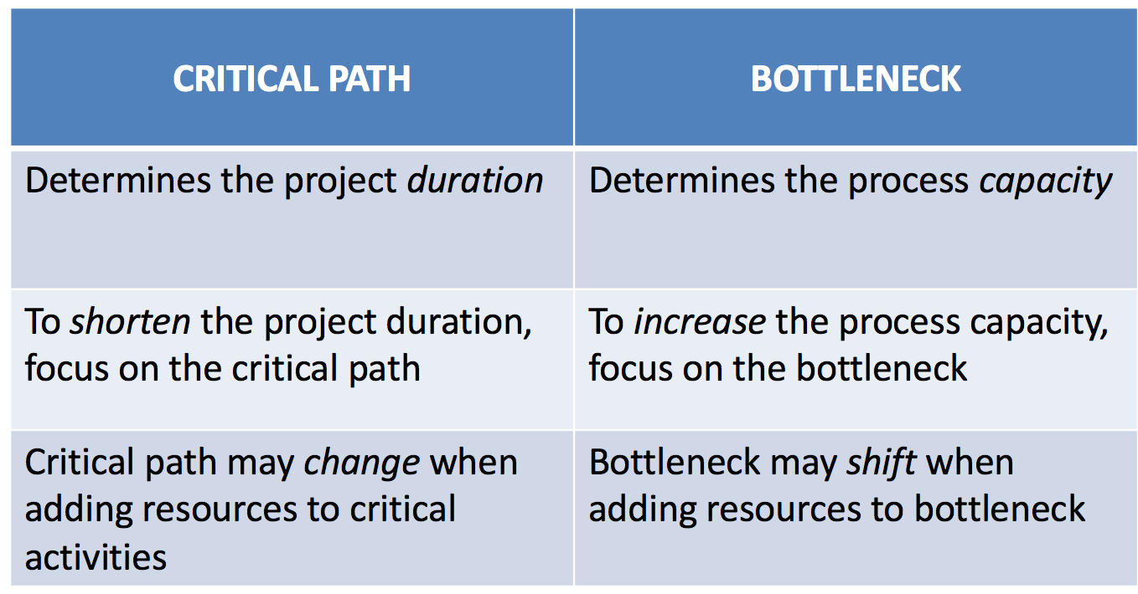

We can reduce project duration by “crashing” or reducing the duration of certain activities.

Crashing: an activity refers to reducing the time it takes to complete the activity

Crash time: the minimum possible time to complete an activity (smaller than the normal time)

Crash cost: the cost associated with the crash time (in place of the normal cost)

We allow partial crashing with proportional cost

Let’s look at this example project.

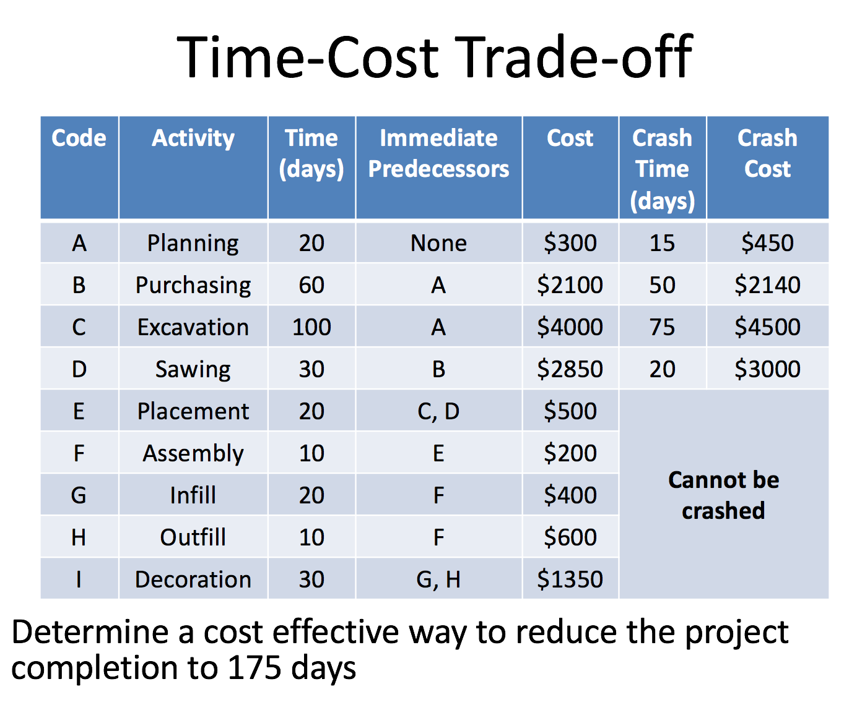

We draw the CP diagram first. Then we annotate the crash options available.

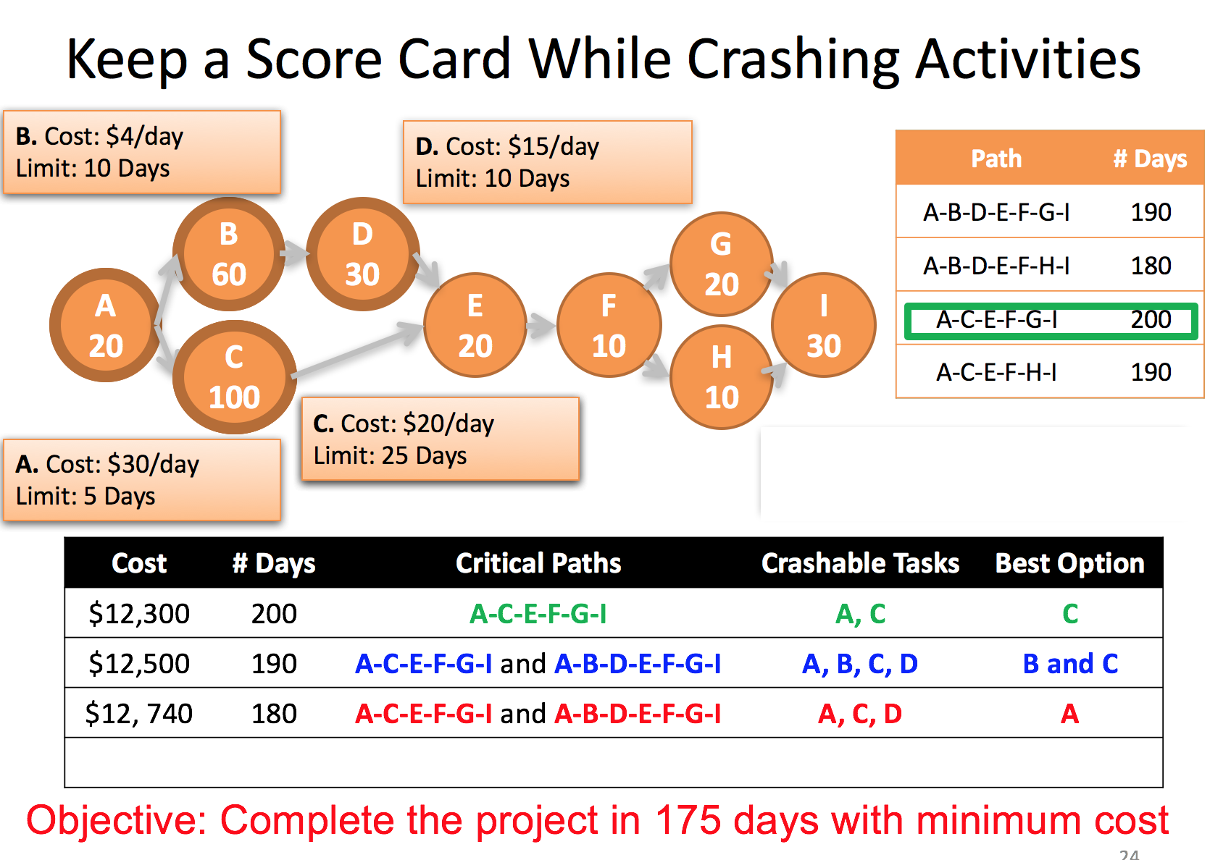

Crash cost is total cost of activity if you crash it, crash time is total time of activity if you crash it. Cost/day calculated by taking (crash cost – original cost)/(original time – crash time) so for A: (450-300)/(20-15).

First identify critical path (A-C-E-F-G-I), then identify what you can crash on it (A and C). Crash the lowest cost one until the point where the critical path is no longer the critical path (here, if you crash 10 days, A-B-D-E-F-G-I also becomes a critical path).

Now you have two critical paths. To reduce project duration, you can either crash just A, or crash some combination of activities on each; essentially, we must crash C + either B or D. We will of course, choose lowest cost option. A costs 30/day, B and C costs 24/day, D and C costs 35/day. Of course, we crash B and C first as much as we can (10 day limit).

Now we’re at 80 days total duration, need to crash 5 more days. Options are A (30/day) or D and C (35/day). Crash A of course, 5 days to get to target of 75 days duration.

Budgeting and scheduling

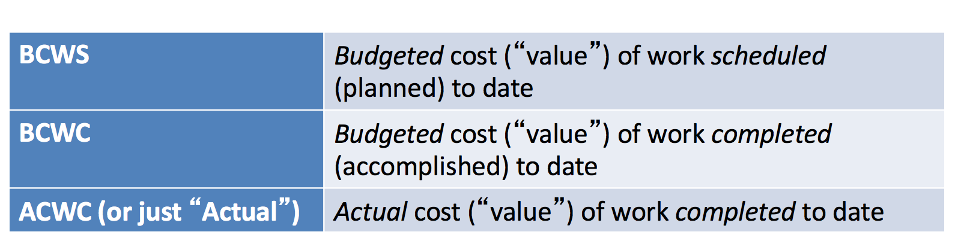

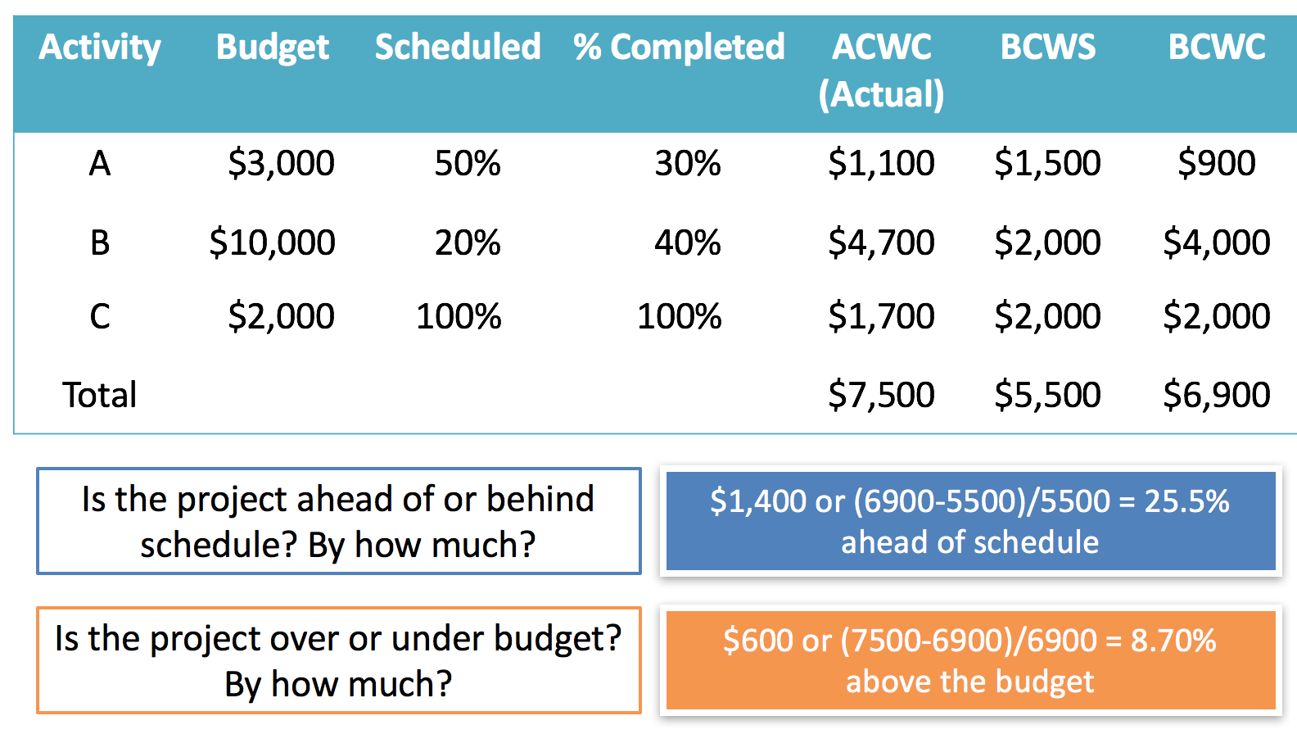

Pretty straightforward. You gotta compare budgeted cost of work scheduled with budgeted cost of work completed to find if you’re ahead of or behind schedule. Compare actual cost of work completed with budgeted cost of work completed to find if you’re over or under budget.

**Inventory: EOQ**

What is inventory? Essentially anything. Finished products, WIP, consumable stuff you use to make other stuff…

Types of inventory:

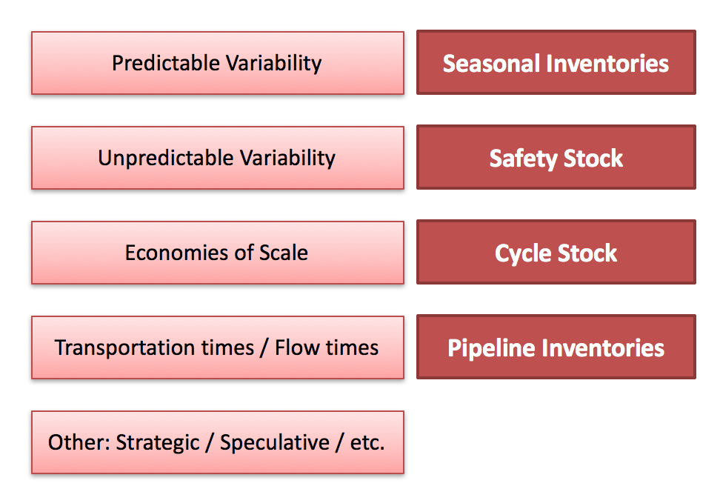

Cycle stock corresponds with EOQ.

Inventory classification:

Percentages approximate — iPhone example considering materials as Foxconn’s inventory:

Type A = small groups of high volume items; Accounts for 15% by the number of parts, and 70-80% of the total sales of all parts. (glass OLED panel)

Type B = Accounts for 35% of the number of parts, and 10-15% of the total value (chips/battery)

Type C = Accounts for 50% of the total number of parts, and for 5-10% of the total value (screws and stuff)

Two trade-offs when deciding on how much/when to order (which determines how much inventory to hold). 1. The cost of ordering (literally the cost of placing the order and then receiving it and organizing/shelving it) vs. cost of holding inventory (opportunity or storage costs usually). 2. Cost of running out vs. cost of ordering too much. First trade-off will be dealt with in EOQ, second will be in newsvendor.

**EOQ: Given demand rate, and cost information, find the optimal Q to order.**

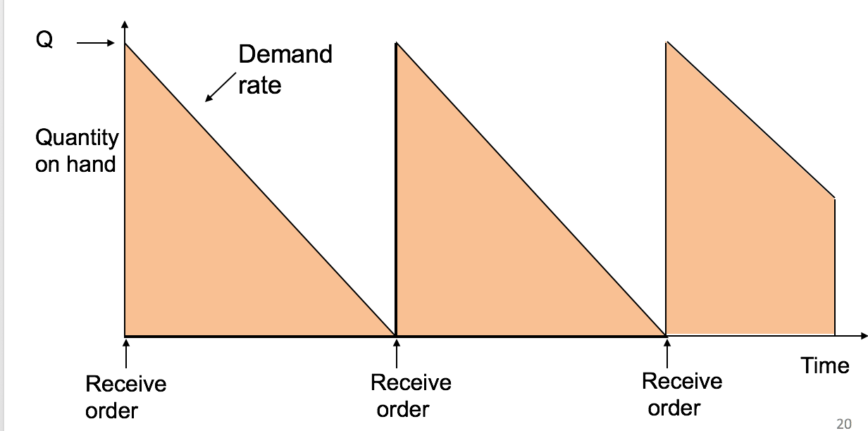

Ordering (or setup) costs

– Costs incurred during the start of each ‘new order’: Transportation cost, Order processing cost. Do not count ‘sunk’ costs (e.g. overhead not related to new order). Fixed costs per order can be reduced/spread via economies of scale,

Holding (or carrying) costs

– Costs for storage, handling, insurance, working capital tied up, etc.

- As a meaninglessly confusing convention, we tend to express holding costs as an (annualized) % of total unit cost.

How does it work? First some notation.

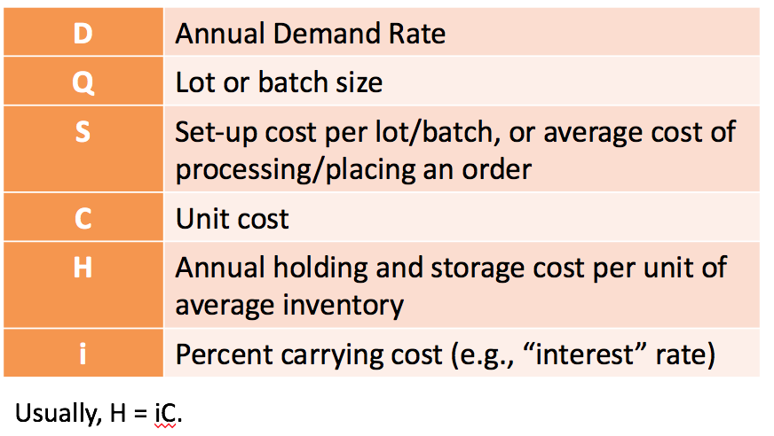

So we have our two costs, inventory holding cost and ordering costs. Total cost is the sum of these. Q/2*H = total holding cost (Q/2 is average inventory, times annual holding cost per unit of inventory = total holding cost). D/Q*S is total ordering cost (Annual demand/Quantity Ordered per Order = number of orders you make in a year because we assume you fill all demand. S is ordering cost per order.) You can change the timing to not be annual as long as your timing is consistent.

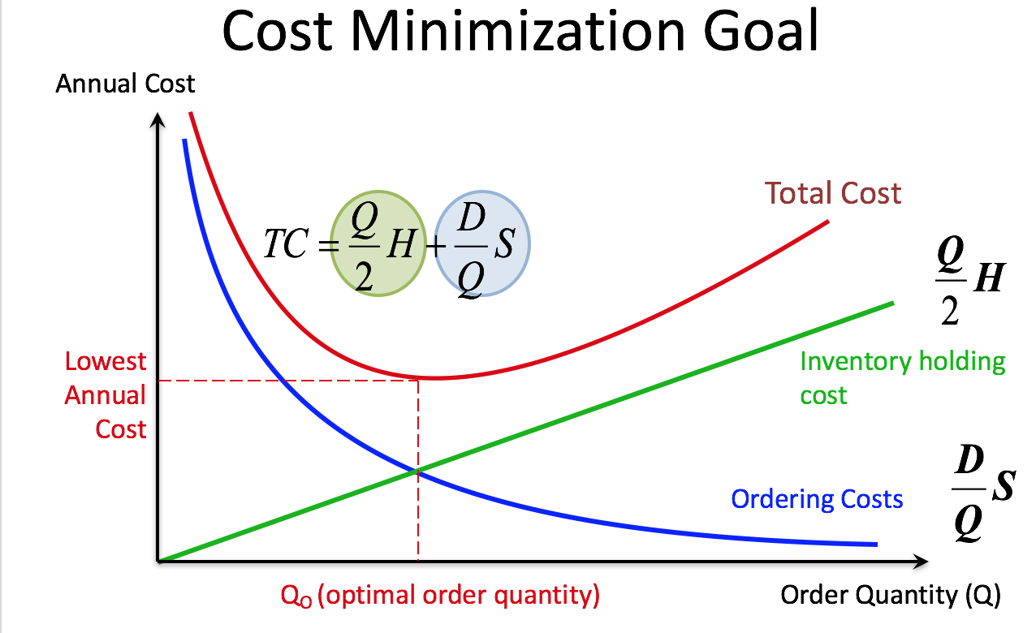

To minimize total cost, you set inventory holding cost and ordering cost equal. Some quick dumb algebra will get you to this formula for Q:

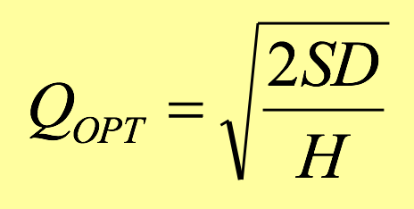

When you use this formula, you will get the optimal quantity you must order every time you run out of inventory. If you plug this Q back into Holding cost and ordering cost formulas above, usually with some rounding error, you’ll find they are (approximately) equal. If they are very different, you messed something up.

Orders per year = annual demand/Qopt. Cycle time (in yrs) = 365/orders per year.

EOQ assumes you get your order immediately. Not very useful.

**Inventory: Newsvendor**

**Balancing costs of over-ordering vs. under-ordering. Only really useful if you’re ordering something that you’re never gonna order again (newspaper for a certain day, fashion, tickets to an event etc.)**

Cu = cost of under-ordering (lost sales, opp costs), Co = cost of over-ordering (liquidation).

Co is relative to price you liquidate for (unit cost - liquidation price = cost of liquidate)

Cu is relative to actual selling price (selling price/shirt – cost/shirt = lost profit/shirt).

Some more algebra involving setting marginal cost of overage = marginal cost of underage, gets you this formula:

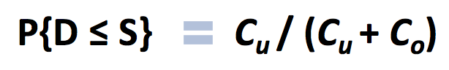

This is your “Critical fractile/critical ratio”. It’s actually more of a probability. You should order an amount such that the probability of not stocking out (also called “service level”, or how many customers you expect to serve) = this “ratio”. So, get this probability, do Z inverse to get a Z-score (remember how those work?) and follow this formula to calculate how many you need to order: S = mean(demand) + Z*stdev(demand)

Usually will give you enough info to calculate Co and Cu, and mean/stdev of demand, and a probability/Z table.

**Kind of related but different model from newsvendor is discrete demand**

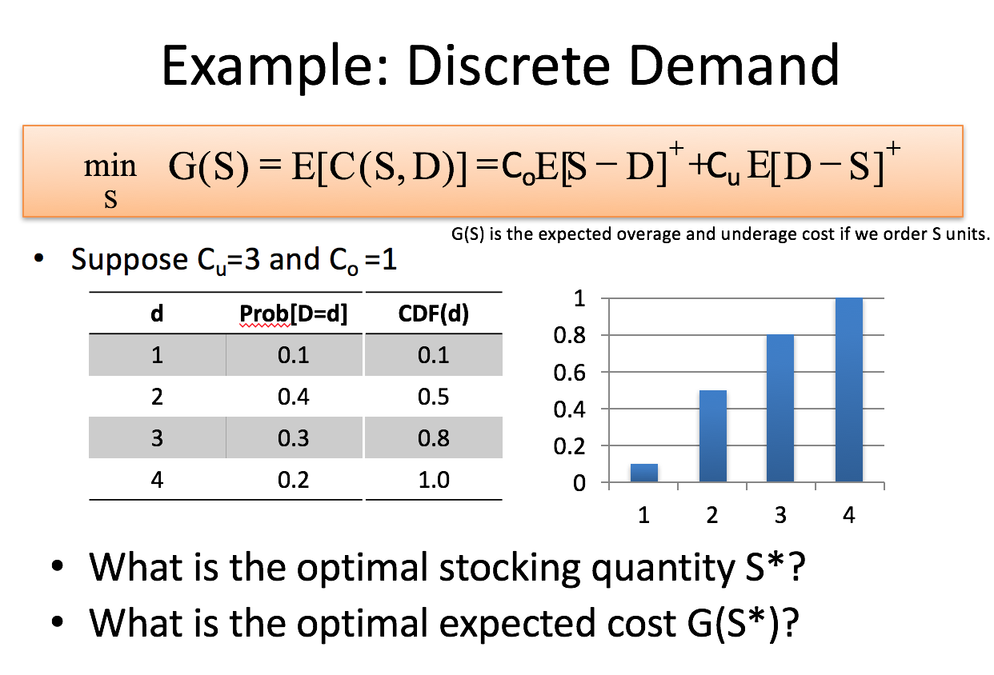

You may have to calculate CDF(d) column yourself (not that hard, just add the Prob(D=d) up until d.

Lecture slides calculates expected cost for each d then finds minimum from that. That’s way too much work. Fastest way to do this is calculate critical ratio (3/(1+3)) = 0.75 then find the smallest S (order amount) such that CDF(d) is just greater than the critical ratio. So, 0.8 in table above is just greater than our critical ratio of 0.5. We order 3 units.

**Inventory: Lead Time**

Up until now we assumed that you order when you have nothing, and you get your order immediately. This is a pretty terrible assumption for some industries. Annoyingly, we now have to throw out this assumption and revisit all relevant models above (EOQ and discrete demand) assuming you order before you run out of inventory to accommodate for the fact that it’ll take a while to arrive. Note, Newsvendor model is relatively unaffected because you only order a product one time.

**EOQ with reorder point:**

**Basically, EOQ (how much you order) is the same. You just need to decide WHEN to order (at what level of inventory do you say “oh shi… gotta order more now”).**

Slide full of acronyms/initialisms:

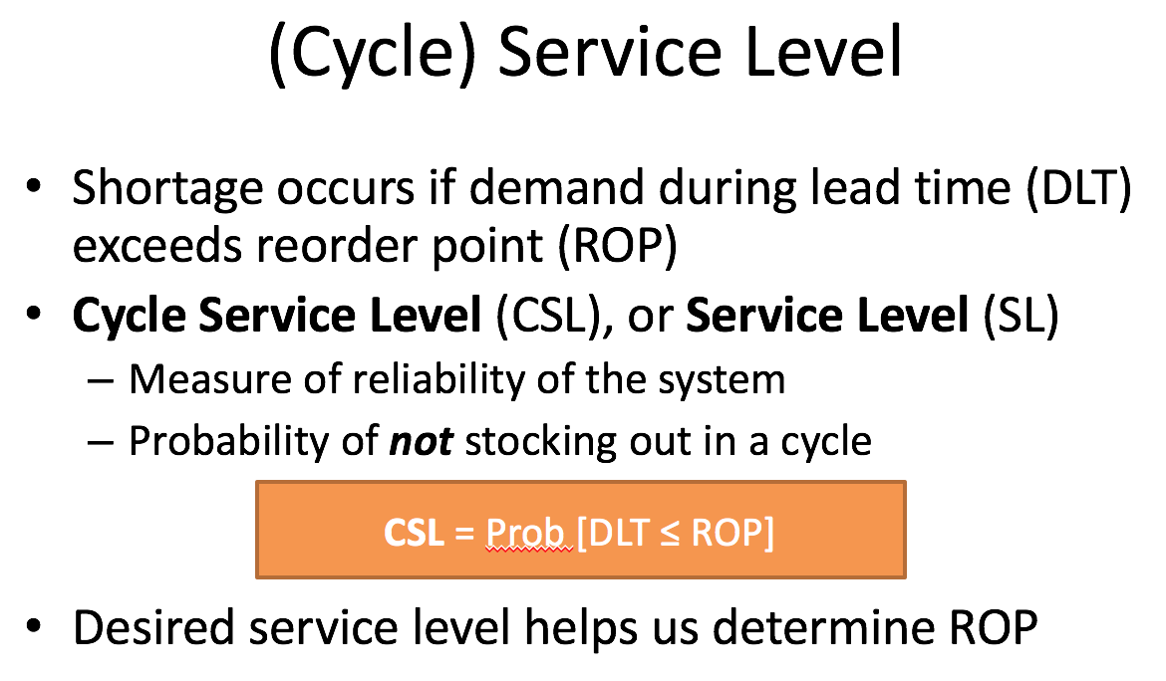

Essentially, this is EOQ but applies some concepts from newsvendor, so it’s kind of confusing, but it is NOT newsvendor. You are setting a re-order point (when you look at how much inventory you have and you go “oh sh.. gotta order more”), and you are setting this point high enough such that you have enough inventory sitting around to cover demand to some service level (%) during the time it takes the new order to arrive.

Cycle service level (CSL) is the probability that your reorder point inventory is enough to cover demand during lead time (DLT). You choose this probability.

 🡪 This is the reorder point formula. It’s just the mean demand during lead time plus the appropriate Z score (which you get by norminv() the service level you want) times standard deviation of demand in lead time. So if you say you want a 99% service level, mean of lead time demand = 1, stdev of lead time demand = 1, you get a z-score of 3.33. If you set your reorder point to 1+3.33 = 4.33, you have a 99% chance of meeting demand, or rather, theres a 99% chance that demand won’t exceed this level, because that’s how normal distributions work.

**Confusing notation, because otherwise it’d be too easy:**

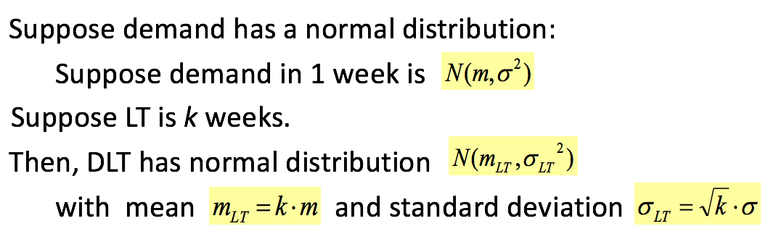

so m is average weekly demand, k is lead time in weeks, multiply them and you get average lead time demand. Standard deviation calculation involves square rooting k because that’s how multiplying standard deviation by a constant works in stats.

Safety stock is defined as the excess amount you order above “expected” aka mean demand during lead time (DLT). SS = ROP – (D·LT) where DLT is just K*M = mLT so your safety stock is just the standard deviation * Z term  in the EOQ with reorder point formula.

We must then adjust our average inventory formula as it’s no longer just Q/2 (which is the case in normal EOQ, because you order when there is no inventory left, and it arrives immediately. Just add SS so it’s Q/2+SS+pipeline inventory (if it exists, if company counts inventory that is on route. Usually ignore the pipeline inventory part).

Exam question will usually give you mean weekly demand, standarddev weekly demand, lead time, service level and ask you to calculate optimal EOQ (using original EOQ formula), mean demand in lead time, SS, add them to get ROP.

Or they might give you ROP and EOQ, and mean and stdev weekly demand, lead time, and ask you to back out SS (which is just ROP – EOQ), back out service level (SS/stdev to get Z, use a CDF table to find the % Z corresponds to).

In both cases, you may need to calculate average inventory (cycle stock of Q/2 + SS) and average time spent by inventory (I=RxT), find T using average inventory I and R as demand rate. Your T will be in the same units of time as R.

Since you can’t really norminv() in an exam, you’ll either get a table to find the Z, or you’ll just get this:

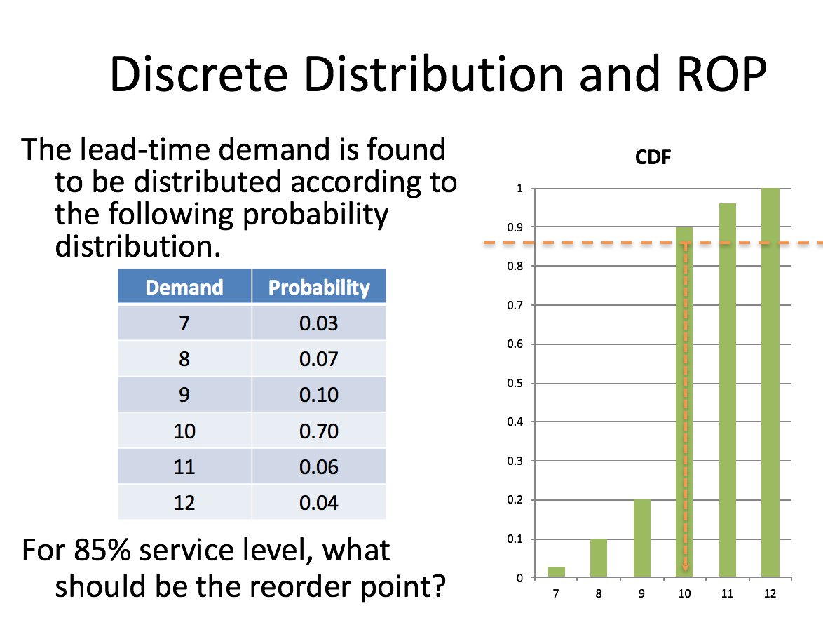

Fill rate formula:

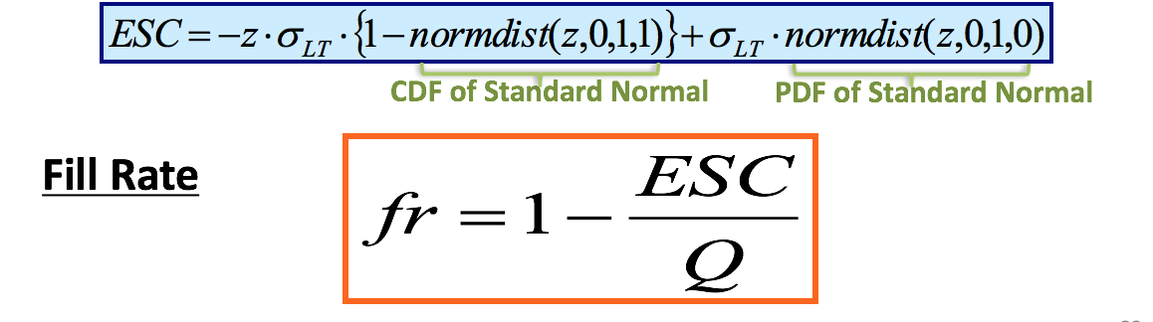

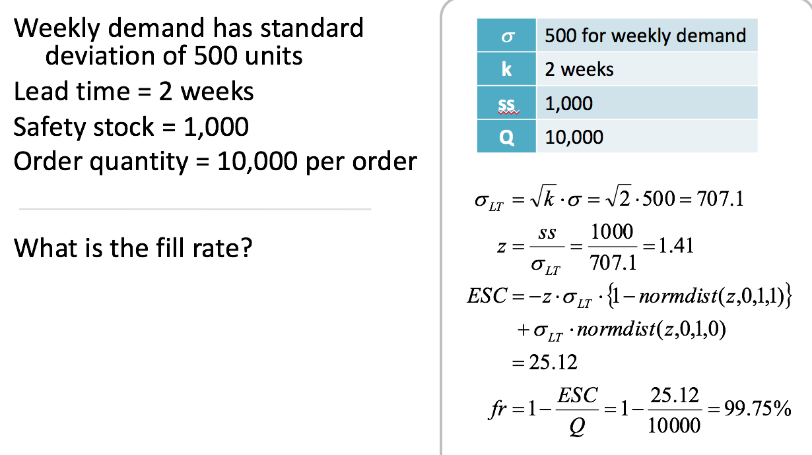

normdist(z,0,1,1) is a cumulative probability of a z score given a standard normal distribution function (mean = 0, stdev = 1) and normdist(z,0,1,0) is the same but not a cumulative probability. I don’t know why we use a standard normal distribution or why the ESC formula even works, and I doubt you need to know either.

This has all been the continuous review system where you constantly check inventory and you only reorder when it dips below a certain quantity (ROP).

In a periodic review system, you check every x days/weeks, then make an order based on how much you want to have (demand for the review period/time between reviews + demand for lead time) and how much you currently have.

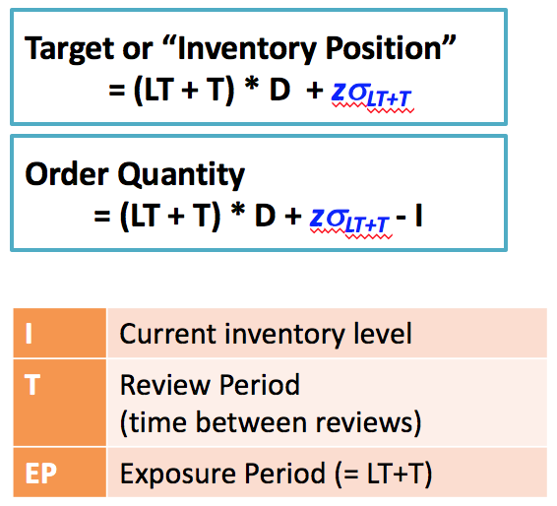

Of course, you order enough such that whatever inventory you have + order amount covers this target amount (so it’s target amount subtract I). You add safety stock (blue part), if demand is uncertain. NOTE: Safety stock in periodic review model involves standard deviation of demand in **both** lead time and reorder period, as opposed to just lead time in the EOQ with safety stock model.

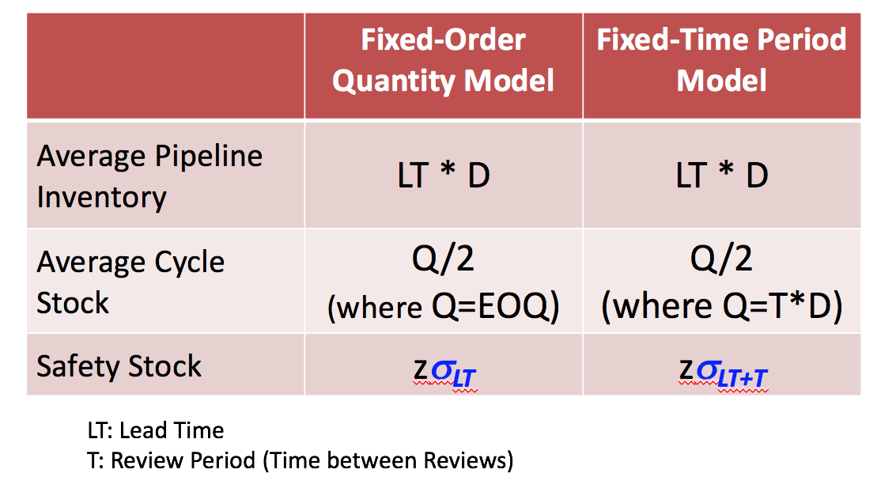

**Forecasting**

**Moving averages (e.g. 2 week, 3 week, or 6 week):** Just take the average demand over the past 2 weeks, 3 weeks, or 6 weeks and use that as your forecast for next week.

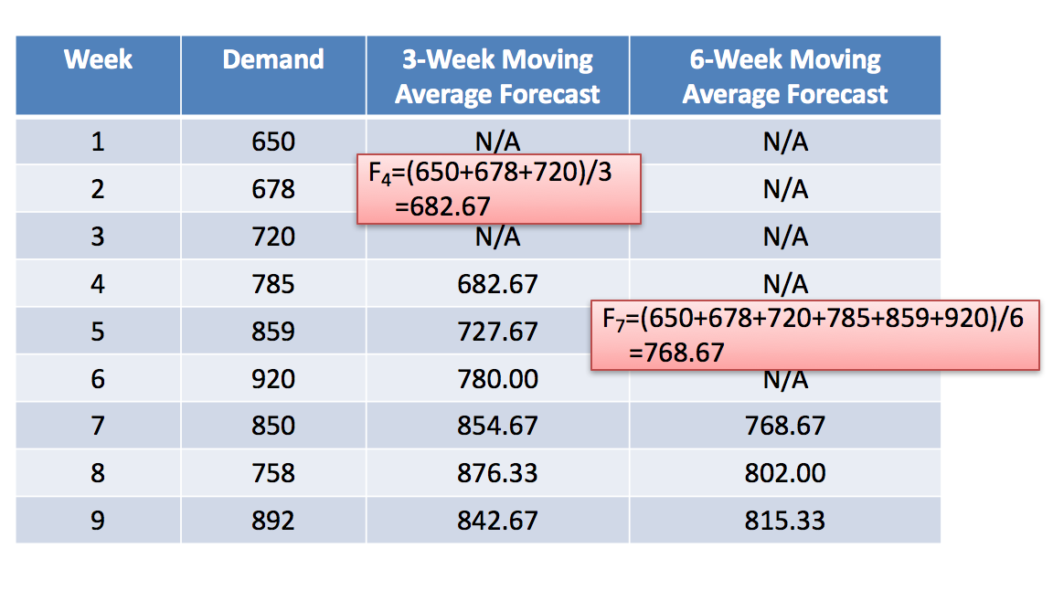

No real rule about which period moving average is the “best” forecast. Just depends on your demand characteristics. Usually more periods = more data = more reliable as the effect of random errors “cancel each other out”. If your demand is growing week over week (if there is a trend), a 6-week moving average would be worse than a 2-week moving average! So, in general, if you have continuing trend in demand, use fewer periods, if not, use more periods.

You can use a weighted moving average where you weigh recent periods greater



where w1>w2>w3… and w1+w2+w3… =1

Exponential smoothing:

Forecast for next period = forecast for previous period + a (some parameter you choose btwn 0 and 1) * how wrong you were (Actual minus forecast).



Aggregate forecasts are always more accurate than disaggregated forecast (forecasting total clothing sales easier than forecasting sales of blue jeans, for example). This is an example of “risk-pooling”.

**How to tell if your forecast is any good**

MAD = mean absolute deviation = retrospectively calculating how wrong you were

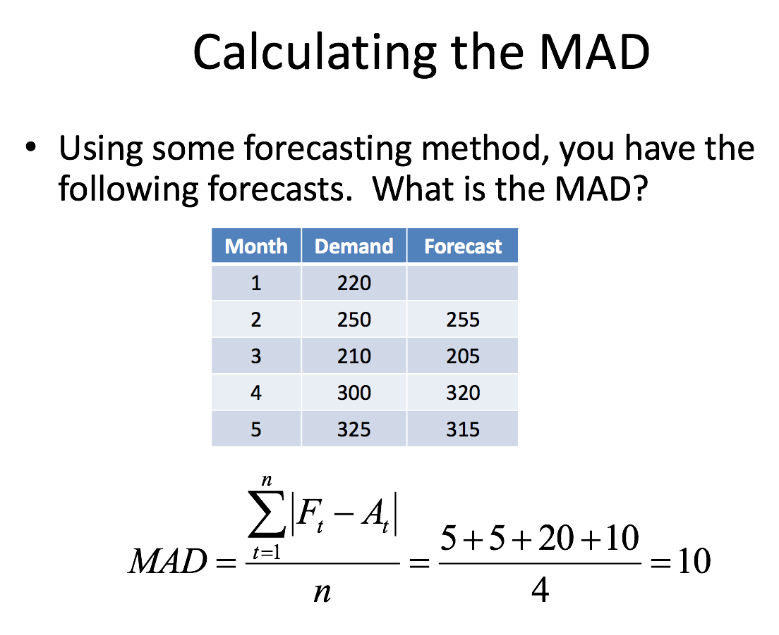

Useful for comparing different forecast methods, minimize MAD.

Not going to bother making practice questions for forecasting, just practice off the examples in slides/on canvas. It ain’t that hard.

**Practice Questions**

**1.** **For the following project, draw the network diagram (critical path diagram), find the critical path and determine time it takes to complete the project**

|  |  |  |  |  |  |
| --- | --- | --- | --- | --- | --- |
| Activity | Normal Time | Normal Costs | Crash Time | Crash Costs | Precedents |
| A | 15 | 1500 | 10 | 2500 | None |
| B | 18 | 3000 | 10 | 3800 | None |
| C | 25 | 4000 | 19 | 5000 | None |
| D | 10 | 2500 | 5 | 2400 | A |
| E | 15 | 1500 | 18 | 1500 | A, B |
| F | 13 | 3800 | 15 | 4800 | B, C |
| G | 15 | 2000 | 14 | 2050 | E, D |

**If activity E duration is shortened by 10 days, by how much will the project’s duration be shortened?**

**How do we shorten the entire project by 5 days (goal is 43 days) while minimizing cost?**

**2.** **If BCWC > BCWS, what does this mean? (Circle Ahead, Behind, or indeterm.)**

Ahead of/Behind schedule or indeterminable

Above/Below budget or indeterminable

**What if ACWC > BCWC?**

Ahead of/Behind schedule or indeterminable

Above/Below budget or indeterminable

**3. Do the Jane Smith Wolvertine Airlines question from your sample final (on Canvas)**

**Do you agree that we should use her redesigned system? Why or why not? To what**

**effect can we attribute the differential in wait times?**

**4. A local seed dispensary maintains a periodic inventory system for sunflower seeds with**

**a safety stock level of 150 kg. An order is placed every 5 weeks and it takes 1 week for**

**orders to arrive. The weekly demand for flour is 600 kg and the standard deviation of**

**this is 80 kg. Assume the demand is normally distributed.**

**A) Today the manager must place an order. He currently has 300 kg of seeds on hand.**

**How much should he order? What is the average cycle stock?**

**B) The manager wants to ensure a 97% cycle service level. If he does this, he expects**

**the shop will need more safety stock under the periodic system than the fixed-order**

**quantity system. Do you agree with this? Hint: relevant z-value = 1.88.**

**C) Assume same dispensary is switching to fixed-order quantity inventory. Order (aka**

**setup) costs are $50/order, annual holding cost is $0.5 per kg. What should the best**

**quantity to order be? What would be the reorder point? What will be average cycle**

**stock, annual total holding cost and annual total ordering costs? Assume the dispensary**

**opens 52 weeks in a year.**

**D) Give some pros and cons to each system**

**5. A newsvendor faces the following demand distribution**

|  |  |
| --- | --- |
| **1** | **0.03** |
| **2** | **0.05** |
| **3** | **0.13** |
| **4** | **0.14** |
| **5** | **0.10** |
| **6** | **0.20** |
| **7** | **0.18** |
| **8** | **0.17** |

**If newspapers sell for $10 and it cost her $6 to buy it, what is the optimal number of newspapers to order? What if the selling price is $7? Unsold newspapers are recycled for $2.**

**Ignore the table above. If we are told only that newspaper demand follows a normal distribution with mean of 5 and stdev of 2, given the same costs/prices, what is optimal Q?**

**Solutions**

**1.** **For the following project, draw the network diagram (critical path diagram), find the critical path and determine time it takes to complete the project**

|  |  |  |  |  |  |
| --- | --- | --- | --- | --- | --- |
| Activity | Normal Time (days) | Normal Costs | Crash Time (days) | Crash Costs | Precedents |
| A | 15 | 1500 | 10 | 2500 | None |
| B | 18 | 3000 | 10 | 3800 | None |
| C | 25 | 4000 | 19 | 5000 | None |
| D | 10 | 2500 | 5 | 2400 | A |
| E | 15 | 1500 | 15 | 1500 | A, B |
| F | 13 | 3800 | 13 | 4800 | B, C |
| G | 15 | 2000 | 14 | 2050 | E, D |

Answer should look something like this but with the times filled in. Start/End optional.

Project length = 48 (critical path = B-E-G).

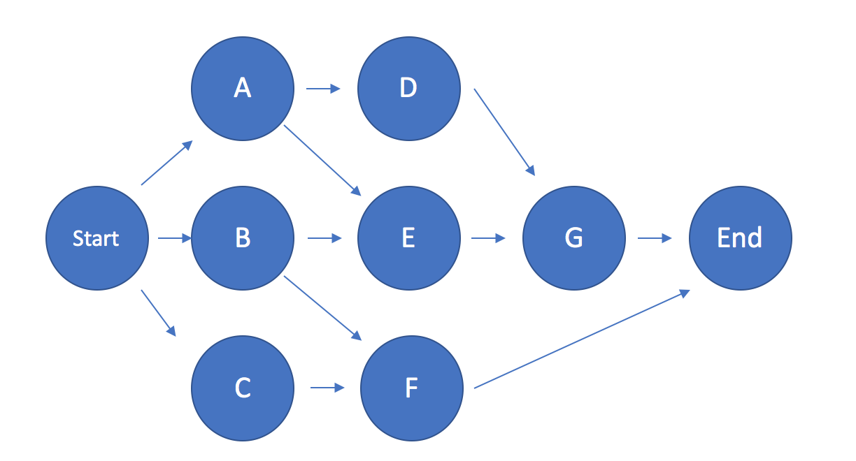

**If activity E duration is shortened by 10 days, by how much will the project’s duration be shortened?**

3 days.

**How do we shorten the entire project by 5 days (goal is 43 days) while minimizing cost?**

Critical path is B-E-G. Crashable tasks are B and G. You need to crash this by 3 days before another path becomes critical (A-E-G at 45 days).

Crash cost for B is 100/day (3800-3000)/(18-10), You can’t even crash E and crash cost for G is 50/day.

So, we crash G by 1 day.

What happens now? It cost us an extra 50, and we shortened project duration by 1 day.

Let’s again assess what we can do. Still B-E-G is critical (18+15+14 = 47 days now), but because G was on the path for A-E-G, that path now only takes 44 days. It is still our next longest path however. So, we gotta crash B-E-G again. The only thing we can do is crash B for 3 days at 100/day (can’t crash E/G anymore; crashing 3 days makes the other path critical).

Now proj = 44 days, at a cost of 350. Our critical paths are both A-E-G and B-E-G both taking 15+15+14 = 44 days. To reduce this by one day and reach our goal, we need to crash both A and B. B costs 100/day, A costs 200/day: this crashing costs $300.

Total cost: $650. Crashed G by 1 day, B by 4 days, and A by 1 day.

You should probably make a “scorecard”; but I’m lazy and I hate tables.

**2.** **If BCWC > BCWS, what does this mean? (Circle Ahead, Behind, or indeterm.)**

**Ahead of**/Behind schedule or indeterminable

Above/Below budget **or indeterminable**

**What if ACWC > BCWC?**

Ahead of/Behind schedule or **indeterminable**

**Above**/Below budget or indeterminable

**3. Do the Jane Smith Wolvertine Airlines question from your sample final (on Canvas)**

**Do you agree that we should use her redesigned system? Why or why not? To what**

**effect can we attribute the differential in wait times?**

No, her system is dumb. Economy class passengers wait an hour on average; that’s

atrocious. Attribute the differential to risk-pooling in a single queue system.

**4. A local seed dispensary maintains a periodic inventory system for sunflower seeds with**

**a safety stock level of 150 kg. An order is placed every 5 weeks and it takes 1 week for**

**orders to arrive. The weekly demand for seeds is 600 kg and the standard deviation of**

**this is 80 kg. Assume the demand is normally distributed.**

**A) Today the manager must place an order. He currently has 300 kg of seeds on hand.**

**How much should he order? What is the average cycle stock?**

Order Q = demand for the review period + demand for lead time + safety stock – current

inventory = 600*(5+1)+150-300 = 3450 kg.

Average cycle stock = 600*5/2 = 1500 kg

**B) The manager wants to ensure a 97% cycle service level. If he does this, he expects**

**the shop will need more safety stock under the periodic system than the fixed-order**

**quantity system. Do you agree with this? Hint: relevant z-value = 1.88.**

Yes. Under periodic review, SS = 1.88*sqrt((5+1)*6400)) = 368 kg.

Under fixed order, SS = 1.88*(80) = 150.4

Remember, in periodic, your safety stock will be Z * standard deviation of demand during

lead PLUS review time vs. Z * standard deviation of lead time in the fixed-order system.

**C) Assume same dispensary is switching to fixed-order quantity inventory. Order (aka**

**setup) costs are $50/order, annual holding cost is $0.5 per kg. What should the best**

**quantity to order be? What would be the reorder point? What will be average cycle**

**stock, annual total holding cost and annual total ordering costs? Assume the dispensary**

**opens 52 weeks in a year.**

As we are given holding cost as an annual rate, we would have to either convert that into a weekly rate or convert demand into annual. We do the latter: 600*52=31,200 kg of annual demand.

EOQ formula = sqrt(2*D*S/H) = sqrt(2*31200*50/0.5)= 2498 kg.

Reorder point = 200 (SS)+ 600 (1 week’s worth of demand to cover lead time) = 800

Average cycle stock = EOQ/2 = 1249 kg.

Holding costs = average inventory * annual holding cost = (EOQ/2+SS)*H =

(2498/2+200)*0.5=724.5.

Ordering (setup) costs = D/EOQ * S = 31,200/2498*50=624.5

**D) Give some pros and cons to each system**

EOQ is expensive because you’re always checking. Periodic is easier to schedule and

combine orders for different items if you carry more than 1 item from the same supplier.

**5. A newsvendor faces the following demand distribution**

|  |  |
| --- | --- |
| **1** | **0.03** |
| **2** | **0.05** |
| **3** | **0.13** |
| **4** | **0.14** |
| **5** | **0.10** |
| **6** | **0.20** |
| **7** | **0.18** |
| **8** | **0.17** |

**If newspapers sell for $10 and it cost her $6 to buy it, what is the optimal number of newspapers to order? What if the selling price is $7? Unsold newspapers are recycled for $2.**

If $10, Cu = 10-6 = $4, Co = 6-2 = $4. Cu/(Cu+Co) = 0.5

Going up the cumulative probability table (which you should create), X = 5 or 6

Now we gotta find the expected costs under both x=5 and x=6 to find # he should order. Basically, if you order 5, and demand turns out to be 1 (with probability of 0.03), your expected overage is (5-1)*0.03. Do this for each possible demand (expected overage if demand is 2 is 3*0.05). When you find your total expected overage, multiply by cost of overage i.e. Co. Do the same for understock costs, add expected overage cost and understock cost together to find expected total cost. Pick x = 5 or x = 6 based on minimizing this.

--If X = 5,

Expected understocking = 0.2*1+0.18*2+0.17*3 = 1.07 * Cu = 4.28

Expected overstocking = 0.03*4+0.05*3+0.13*2+0.14*1 = 1.0968 * Co = 4.3872

Total expected cost = 8.6672.

--If X = 6,

Expected understocking = 0.18*1+0.17*2 = 0.52 * Cu = 2.08

Expected overstocking = 0.03*5+0.05*4+0.13*3+0.14*2+.1*1 = 1.12 * Co = 4.48

Total expected cost = 6.56.

6.56 < 8.6672 so X* = 6, order 6.

**Ignore the table above. If we are told only that newspaper demand follows a normal distribution with mean of 5 and stdev of 2, given the same costs/prices, what is optimal Q?**

Cu = Co, Critical ratio = 0.5, so obviously 5.